INTRODUCTION

Scientists have stated that the tipping point into ecological and environmental devastation is a 2°C increase in the average global temperature compared to the pre-industrial baseline. They have also strongly urged that we try to avoid even the 1.5°C threshold, as its effects may take centuries to recover from. To stay below the 1.5°C limit, countries would have to reduce the amount of greenhouse gases (GHGs) they emit each year, working to avoid a global concentration limit set by scientists. This is the basis for the Paris Agreement, a treaty adopted in December 2015 by 197 United Nations countries pledging to fight climate change. Each party submitted emission reduction goals in Intended Nationally Determined Contributions (INDCs) before and Nationally Determined Contributions (NDCs) after its adoption.

The data for this project contains historical GHG emissions from all countries and the benchmarks laid out in their INDCs and NDCs. The trajectory of the historical data was extrapolated forward to 2030 to provide projections of GHG emissions to compare to the goals of the Paris Agreement. The difference will be measured as the emissions gap. The analysis conducted with this data focused on historical global greenhouse gas emissions and identifying the largest contributors to greenhouse gas emissions, both historically and currently. The countries of focus were identified based on their behavior as top emitters in 2015. The top 10 emitters in 2015 will be a primary focus of this analysis.

BACKGROUND & THEORY

Paris Agreement signatories had to submit plans for how and by how much they would lower their GHG emissions through 2020, 2030, and 2050. Such plans, or Intended Nationally Determined Contributions (INDCs) and Nationally Determined Contributions (NDCs) for pre- and post-Agreement plans, respectively, would be reviewed and revised at each benchmark based on the nations' achievements toward their GHG target. In a ramp-up style, the Agreement requires countries to recommit to more aggressive plans with each consecutive iteration. While NDCs include more than just GHG emission reduction targets, they will be the focus of this project.

It is understood that annual GHG emissions have accelerated exponentially across the globe since the pre-industrial period (often considered by scientists to be 1850 – 1900). In 1992, the United Nations drafted its Framework Convention on Climate Change (UNFCCC) to devise an agreement to limit the increase in GHGs in the atmosphere. This was built upon by the Kyoto Protocol, adopted in 1997, which was later superseded by the Paris Agreement in 2015. Each successive treaty was more aggressive and urgent in its goals. However, we continued to see rising atmospheric GHG concentrations and greater yearly emissions during that time. We also saw accelerated effects of climate change. So far, no treaty has had much success in its attempt to curb the impacts of climate change.

This project aimed to examine how well the parties that signed the Paris Agreement are meeting their goals. Based on what they need to reduce to by a particular year and where they are now, are they on track to limit warming? Which countries have the greatest impacts – whether they achieve or fail – on the global limit goal?

HYPOTHESIS

Despite having lower emissions than those on their pre-2016 business-as-usual (BAU) trajectories, I expect most nations will fall short of their reduction goals. Their predicted emissions for 2030 will exceed the pledged emissions cap. Larger countries, such as the United States, will have more significant impacts on global emissions. I suspect many of these larger nations will not meet their goals. I predict that the gap between actual and pledged emissions for 2030 will be lower than it would have been without the adoption of the Paris Agreement for industrialized nations but may not be the case for developing nations that are still industrializing. I expect the actual global emissions gap for 2020 to be significant, as will the estimated gap for 2030. I believe that the top emitters will include the United States, China, and India based on population and economic activity.

DATA

The primary dataset of historical emissions was the PIK PRIMAP historical emissions dataset,[1] which was chosen for its thoroughness. It includes all Kyoto Protocol GHGs, which are used by the Intergovernmental Panel on Climate Change (IPCC) and UNFCCC for their global-standard reports. While country-reported data was prioritized, third-party data was collected to fill in where nationally reported data was unavailable. The list of emissions sectors and categories used is also comprehensive.

An additional dataset was created containing the NDCs of the countries investigated and the global benchmarks established by scientists necessary to stay under the 1.5 and 2°C thresholds.[2] [3] The data was collected from various sources and underwent any transformations needed to get the required metrics.

ANALYSIS

It should be noted that the emissions data used excluded calculations for Land Use, Land Use Change, and Forestry (LULUCF). This sector covers GHG emissions and removals from human-induced land use, including deforestation, reforestation, and afforestation; cropland, grazing land, and forest management; and revegetation. This is important for affecting the amount of carbon dioxide in the atmosphere, but there is no common framework for LULUCF accounting. Many INDCs and NDCs, along with the data provided by governments, lack mention of the necessary assumptions and methods applied to collecting LULUCF data, presenting an issue in consistently tracking international LULUCF data. Even when mentioned, many different methods are used to collect this data, adding to the inconsistency. For this reason, the totals used for analysis exclude LULUCF in this project. The effect of this exclusion was evaluated, and it was found that after 2000, there is not a pronounced effect on the data. Therefore, this author feels confident that it has no significant impact on the underlying assumptions and analysis.

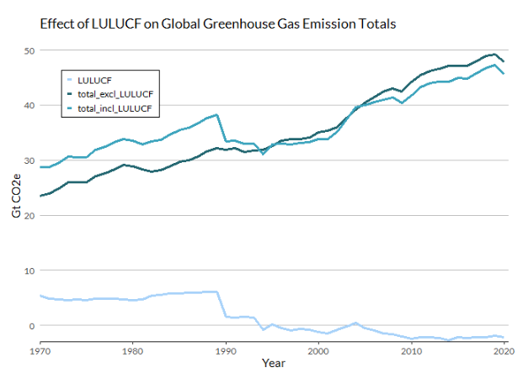

Figure 1

When attempting to lower global GHG emissions, it is important to know which countries have the greatest impact. A few patterns are noticeable when evaluating cumulative historical emissions from 1850 to 2020. Ten countries have the greatest cumulative emissions over the period (in descending order): the United States, China, Russia, India, Germany, the United Kingdom, Japan, France, Ukraine, and Brazil. Figure 2 shows the share of global emissions each of these ten countries make up each year, with all other countries grouped together as “All Others”, from 1950 – 2020. In this period, these ten countries accounted for roughly 50% or more of yearly global emissions. The widening or narrowing of each country’s area on the graph reflects increases or decreases in yearly emissions over time.

Figure 2

The United States saw its most significant changes from the 1870s to the early 1970s. As one of the first countries to industrialize and liberalize its economy, the composition of the United States's economic activity has not seen major change in the last half-century. We see this reflected in the graph: Over the last 40 years, the United States's yearly emissions have increased slightly but have held relatively consistently. Fellow early-industrializers that made the list include France, Germany, and the United Kingdom. By contrast, China, and India, to a lesser extent, show increases over the same period, rising significantly around the turn of the 21st century. These increases in emissions reflect the countries' efforts to rapidly industrialize in recent decades and open their economies to global markets.

Population plays an essential role as well. If this data were represented in emissions per capita, it could significantly change the composition of these rankings. The United States, China, and India occupy large, densely populated territories. The United States has a large, relatively stable population. While China and India also have large populations, they saw theirs boom in the latter half of the twentieth century. A large share of these countries' emissions is likely, in part, due to their large populations.

The combination of early industrialization, a large economy, and a large population provide the foundation for the United States being the largest single contributor to Earth's greenhouse gas concentrations since 1850.

Table 1. Top 10 Cumulative Emitters, 1850 – 2020

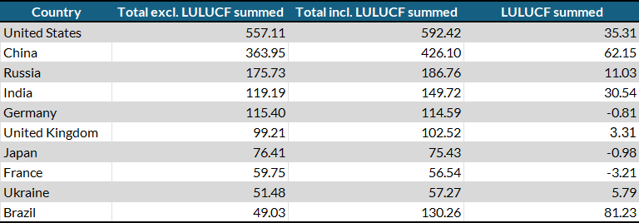

The nations of focus for the projections were determined by the highest emissions at the time the Paris Agreement was signed and NDCs were being crafted. Comparing the largest cumulative emitters since 1850 to the largest emitters of 2015, we see some countries appear on both lists. In 2015, the ten countries that emitted the most GHGs were, in descending order: China, the United States, India, Russia, Japan, Brazil, Iran, Germany, Indonesia, and Saudi Arabia. Together, these "Top Contributors" made up nearly 2/3 (64.5%) of global emissions that year (Figure 3). This effect is noticeable in the data – aggregated historical emissions of those ten mirrors the global emissions data nearly perfectly since 1900. Since 1980, this group of countries has constituted roughly the same percentage of global emissions each year, reflecting the massive effect these countries have on the aggregate.

Table 2. 2015 Top Emitters

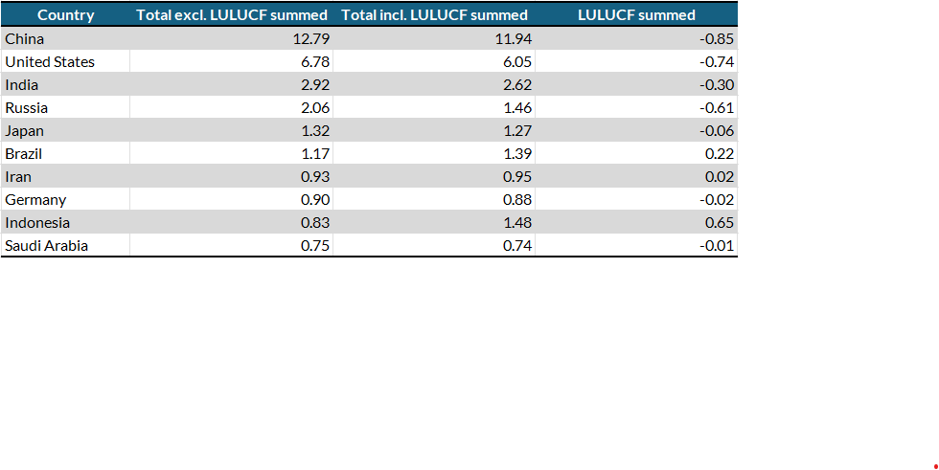

Figure 3

The Top Contributors submitted INDCs in the fall of 2015 as part of their intention to sign the Paris Agreement at the UNFCCC's twenty-first session of the Conference of the Parties (COP 21) that November. These INDCs, and their later NDCs, were aggregated to evaluate their combined proposed trajectory (with immediate implementation) (Figure 4). Historical data for the sum of the Top Contributors and the global total were used to predict each grouping's yearly emission trajectory for 2021 through 2030. First, a BAU line, reflecting behavior before 2016, was predicted to estimate emissions if pre-INDC policies were maintained. Next, 2015 to 2020 served as each group's post-INDC and NDC policy behavior period. That data was extrapolated to predict what emission levels are expected to be in the 2020 - 2030 period if the post-Paris Agreement behavior remains unchanged.

Figure 4

2021 is a unique year to investigate these actions. Global data through 2020 has been collected and calculated, and reflection can be done on pre-2020 pledges (Cancun Pledges, Doha Amendment) before entering the 2021-2030 interval of the Paris Agreement.. In Figure 4, the collective pre-2020 goals for the Top Contributors can be seen on the INDC and NDC lines at the year 2020. This provides a connection between their behavior at the time they were making their post-2020 pledges and their shortcomings of meeting their pre-2020 pledges. The steepness of the line reflects the degree of change they would need to make to be on track. This year is also significant because we have reached the first step in the 5-year ambition-raising cycle of the Paris Agreement. Prior to COP 26 this fall, parties were requested to submit new or updated NDCs that represent a progression in intention and actions compared to their first NDCs.

For the years 2016 to 2020, global emissions, and those of the Top Contributors, were lower than their BAU predictions were estimated to be. However, the decrease in yearly emissions came nowhere close to as low as needed to reach 2020 pledges or be on track to reach 2030 pledges. When aggregating the pledges for the period ending in 2020, their yearly emissions were meant to be lowered to 20.06 Gt of CO2 equivalent by 2020. The collected data from that year shows that the actual aggregate was 31.18 Gt of CO2 equivalent – more than 10 Gt more than the goal.

The INDC and NDCs these countries submitted were significantly more ambitious than their pre-2020 targets: 15.15 and 15.25 Gt CO2e before 2030, respectively.[4] However, estimates show that emissions will continue to increase from 2020 to 2030. Additionally, the gap between actual emissions and the pledges will be even larger in 2030 than that for 2020. Compared to the aggregated NDCs for the Top Contributors, estimates put emissions for the year 2030 at 19.02 Gt CO2 equivalent higher than pledged (34.26 against 15.25). This is, however, smaller than the gap between pledged emissions and BAU emissions for the year 2030 (23.34). As noted above, our Top Contributors collectively failed to meet their pre-2020 pledges and are on track to fail to meet the pledges of their current NDCs. Plans will need to be considerably more aggressive in the next round of NDCs and actions must be more urgent throughout the decade if members hope to close the gap.

Figure 5

As previously stated, the main goal of the Paris Agreement is to limit global warming to 2°C while making best efforts to stay below 1.5°C compared with pre-industrial levels. In its Fifth Assessment Report[5], the IPCC predicts that the paths with a more than 50% chance of occurring require 72% and 49.5% (42-57%) reductions in global GHG concentrations by 2050 as compared to 2010 levels, for 1.5 degrees and 2 degrees, respectively. That means that global emissions in 2030 would need to be 28.28 and 33.26 to be along the 1.5 least-cost and 2°C mean-cost pathways, respectively (Figure 5). Like with the NDCs, there is a large gap between the pathways and predicted global emissions in the year 2030 (23.34 and 18.36 Gt CO2e more in predicted emissions for 1.5 and 2 degrees, respectively). However, like the Top Contributors data, the predicted emissions through 2030 are lower than those predicted for the BAU trajectory (51.61 and 58.14 Gt in 2030). As mentioned, the emissions gap here is significant (29.85 for 1.5°C, 24.88 for 2°C).

Table 3. Goal Emissions, Predicted Emissions, and Predicted Emissions Gaps in 2030

The data reflects that, on the aggregate, countries that have signed onto the Paris Agreement are not doing enough so far to limit warming below 2°C. The largest emitters have not enacted policy changes that put them on track to meet the goals of their NDCs. These nations are also not expected to reach peak emissions before 2030. One goal of the Paris Agreement is to peak as soon as possible; the goal in 2015 was for peak emissions by 2025. The longer it takes for emissions to peak, the more difficult it will be to reach net zero goals and stay on track to limit warming.

CONCLUSION – prob should cut to ~ 300

Climate change is an imminent global crisis that we are already facing the effects of. Scientists state that if we cannot keep global warming below 1.5°C, we will see catastrophic consequences to our environment, including uninhabitable regions resulting in climate refugees, crop failure, and biodiversity decline. Those already disadvantaged, both inter- and intra-nationally, will face the brunt of the effects. Those countries and communities that currently lack, or have been systemically blocked from accessing, the infrastructure, technology, and financial resources to mitigate these changes, will all need particular focus and investment to ensure an equitable approach to climate adaptation and emission reduction efforts. On an international scale, industrialized and wealthy nations, particularly those that are the greatest emitters, should lead the way in investing in developing nations and the Global South. As one of the leaders in both, this is particularly true for the United States. On the national front, domestic policy must reflect this approach. We must fight for those who will be hurt first and greatest, and time is running out.

These countries can make these changes happen. The Montreal Protocol was created in 1987 to reverse the depletion of the ozone layer in the atmosphere by phasing out substances that cause ozone depletion. In 2016, scientists confirmed that the ozone layer was recovering, with the possibility of a full return by 2066. The international cooperation in this treaty is an example of a successful collective, multilateral response to a global climate issue.

Governments and corporations must address and combat climate change through policies that include curbing GHG emissions. These policies require innovative technologies, changing the status quo, and massive investment in both.

1. Link to the dataset & information about the dataset: <https://zenodo.org/records/5494497>

   Citation: Gütschow, J.; Pflüger, M. (2021): The PRIMAP-hist national historical emissions time series v2.3.1 (1750-2019).

   zenodo. doi:10.5281/zenodo.5494497.
2. Sources for NDCs: [Climate Watch NCD Tracker Custom Comparison](https://www.climatewatchdata.org/custom-compare/overview?targets=BRA-pledges%2CBRA-first_ndc%2CBRA-revised_first_ndc), [Climate Watch Explore NDCs](https://www.climatewatchdata.org/ndcs/country/JPN?document=revised_first_ndc),
3. Sources for pathways: IPCC, 2014: Climate Change 2014: Synthesis Report. Contribution of Working Groups I, II and III to the Fifth Assessment Report of the Intergovernmental Panel on Climate Change [Core Writing Team, R.K. Pachauri and L.A. Meyer (eds.)]. IPCC, Geneva, Switzerland, 151 pp.
4. Russia is the only country that submitted an NDC with a less aggressive goal than its INDC, from a maximum effort of 75 Gt CO2e to 70 Gt CO2e.
5. This report was the basis for the Paris Agreements; the Sixth Assessment Report was released this year and will be the basis for the next round of NDCs.